Part1

Part2

1. Create a directory named structure2

* mkdir name : create a directory at the current directory

cd name : allows to enter inside the

directory named name

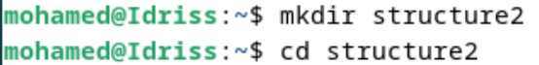

2.

* Create three directories a , b and c touch name : allows the creation of a file

* Create two directories a and c in the directory b. But being in the current directory a we use the path to go back -one level

../b/a : means return one level from de current directory and go to b then a

cd .. : return the previous directory



* Come back to the directory b and then create :

touch a/a : means create a file inside the directory a ( same for touch c/a and touch c/c)

touch c/a c/c : create two file inside c named a and c

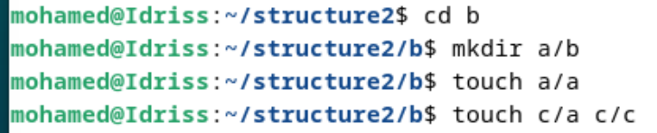

* Using the path ../c/d to come back by one level and create the directory d inside c



Result of the tree :

